Purpose of testing
The purpose of the testing phase is to verify that the network design and implementation for Kgorong Butchery & Deli operates properly and meets the identified client requirements.
VLAN and inter VLAN connectivity testing
Here I verified that the VLAN’s configured for Kgorong Butchery & Deli are all working and the inter VLAN’s routing was working the right way through router1 (R1).
The network division into the VLAN’s
- VLAN 10- Admin
- VLAN 20- Point Of Sale (POS)
- VLAN 30- Staff
- VLAN 40- Contractor WIFI
- VLAN 50- CCTV
- VLAN 60- Management
Each VLAN was then assigned a separate /24 subnet which is therefore within the allocated address block of 10.17.0.0/16 as per the client requirements.
Testing procedure
I used Admin PC 1 which has the IP address of 10.17.10.10 to test the connectivity to the devices and gateways located on the other VLAN’s.
Below are the connectivity tests which were performed:
- Ping from Admin PC 1 to POS device at 10.17.20.10
- Ping from Admin PC 1 to Staff device at 10.17.30.10
- Ping from Admin PC 1 to Contractor wireless device at 10.17.40.10
- Ping from Admin PC 1 to CCTV camera 1 at 10.17.50.11
- Ping from Admin PC 1 to Management VLAN gateway at 10.17.60.1
Below are the screenshots from the above ping’s configurations.

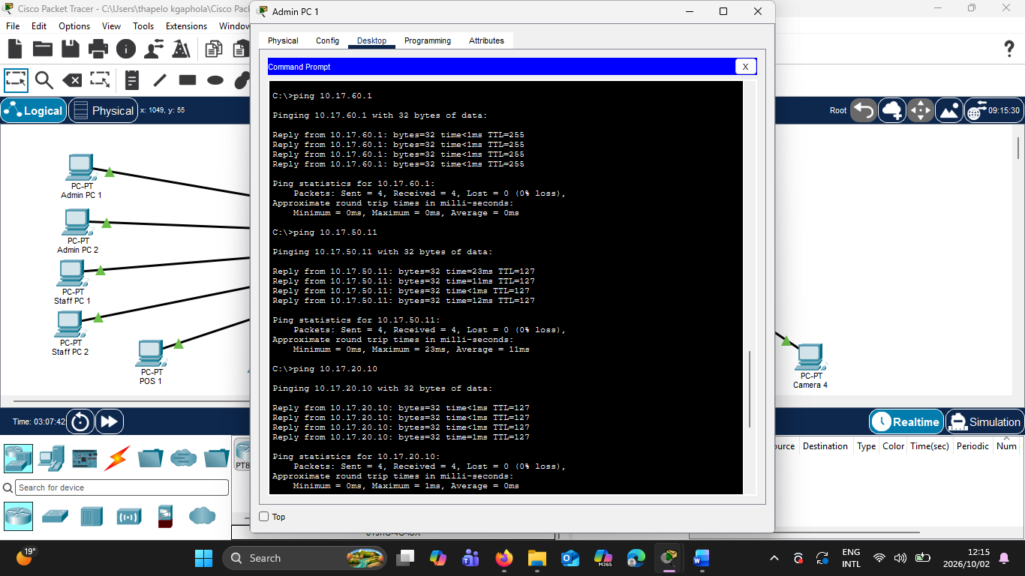
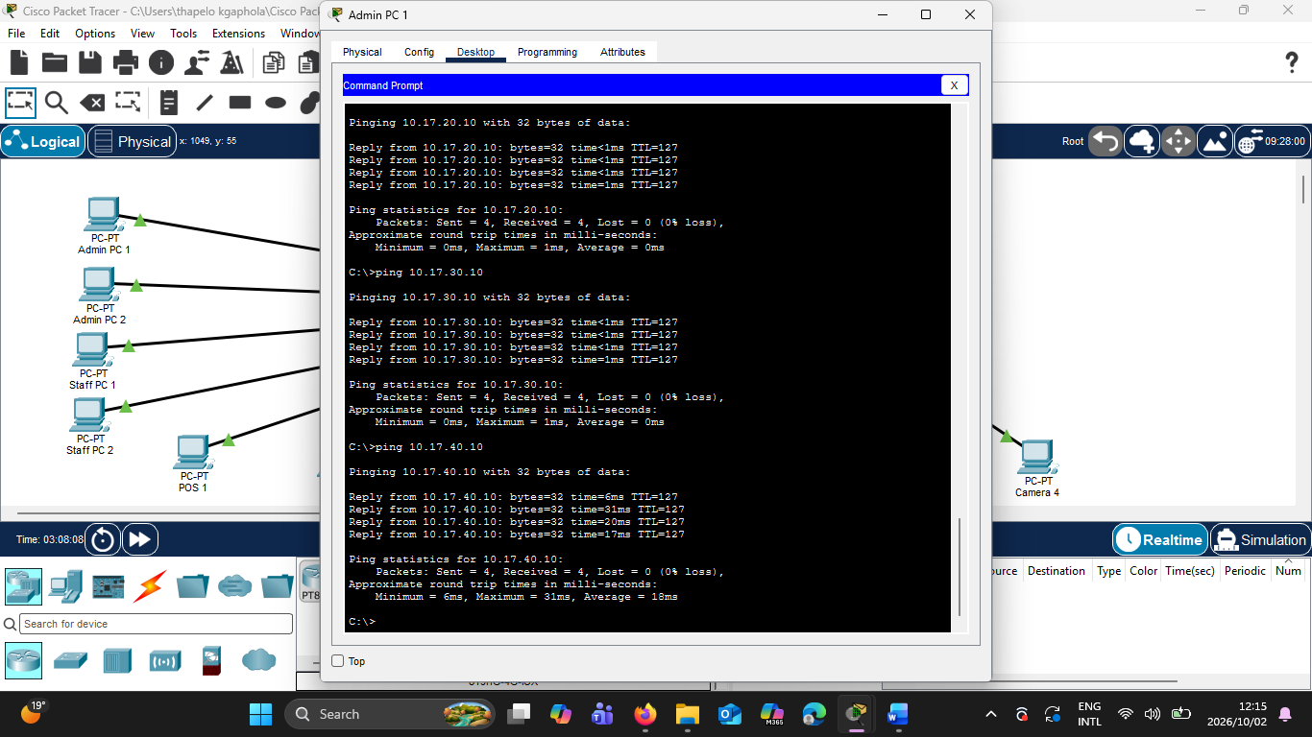
In conclusion, all the ping tests were successful, which means that the connectivity tests demonstrate that the VLAN’s were all working and operational and that R1 was successfully performing inter VLAN routing between the configured networks.

CCTV Segmentation Testing CR7
Here I verified the implementation of the CR7 from my client’s request. I had to add 4 CCTV cameras to the network and their traffic had to be implemented. To meet this requirement, a dedicated VLAN 50 CCTV was created for the CCTV devices. This separates the CCTV devices from the other departmental VLAN’s.
The CCTV network uses the subnet 10.17.50.0/24, with 10.17.50.1 configured as the default gateway on R1.
4 CCTV cameras configuration
- Camera 1 – 10.17.50.11/24
- Camera 2 – 10.17.50.12/24
- Camera 3 – 10.17.50.13/24
- Camera 4 – 10.17.50.14/24
- Default gateway – 10.17.50.1
All four cameras were assigned to the dedicated CCTV VLAN.
Testing Procedure
Connectivity tests were performed to verify that the CCTV devices were correctly configured and reachable through their VLAN.
Below are the tests that were performed:
- Camera 1 was used to ping its default gateway, 10.17.50.1.
- R1 was used to test connectivity to the CCTV cameras.
- Admin PC 1 was used to ping Camera 1 at 10.17.50.11.
- Contractor Laptop 1 was used to attempt to ping Camera 1 at 10.17.50.11 after the contractor access-control list was applied.
Below are screenshots for this testing.
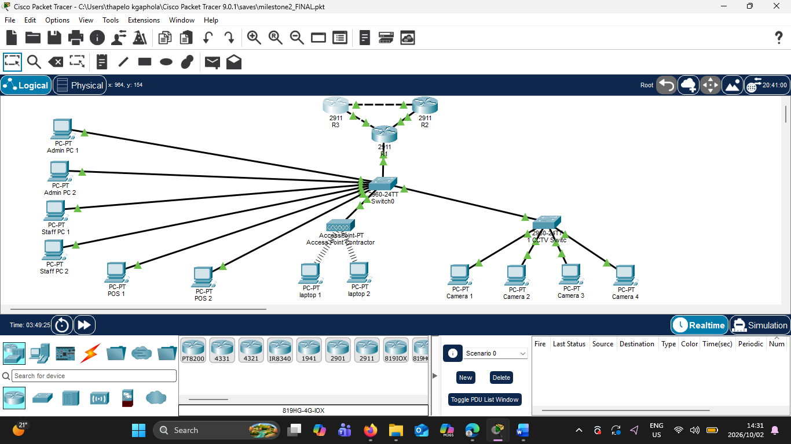
Figure above is the picture of the Topology
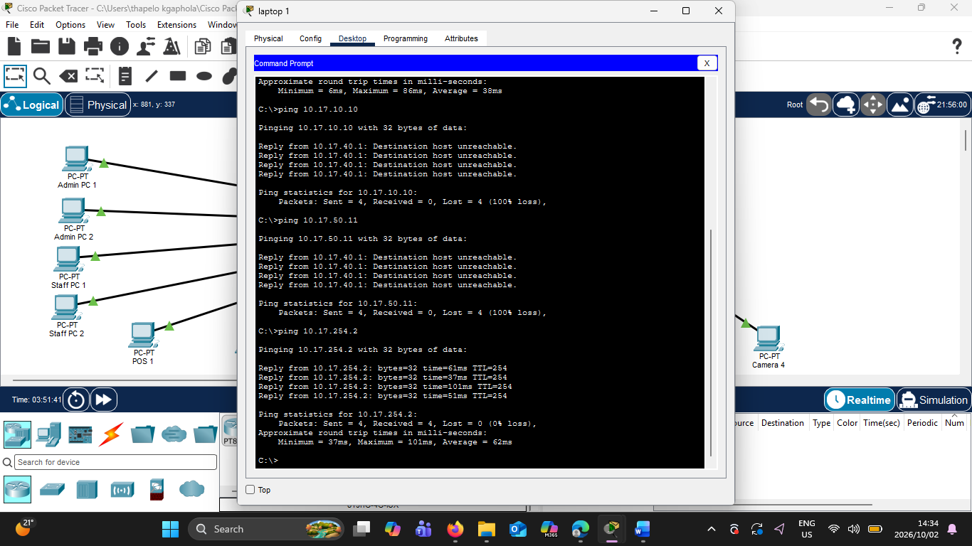 Figure above shows us that the contractor Laptop 1 was blocked from accessing CCTV Camera 1 (10.17.50.11), demonstrating restricted access to VLAN 50.

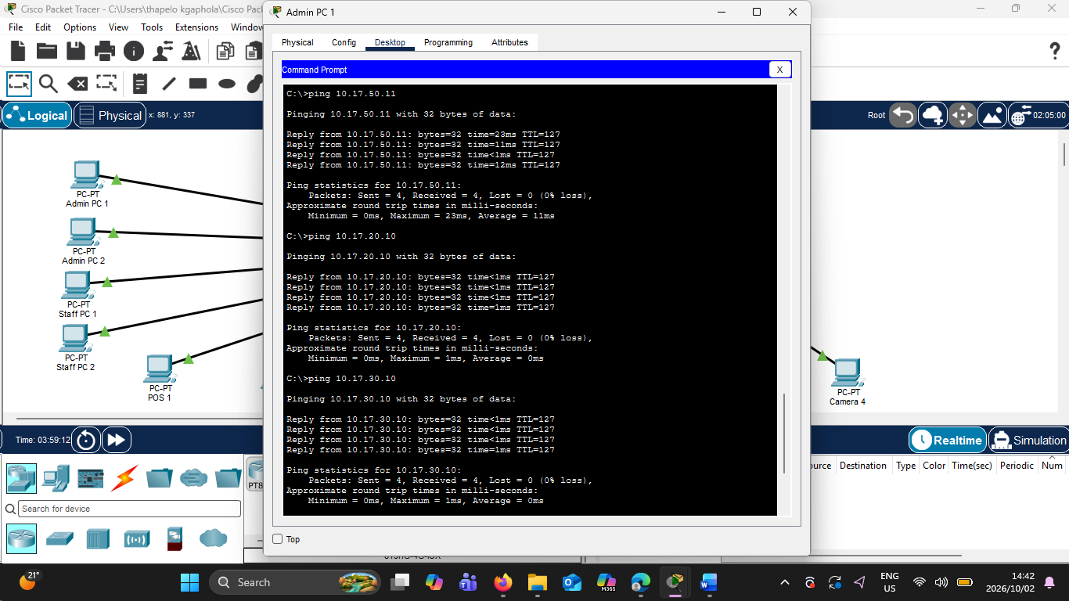
Figure above shows a successful ping from Admin PC 1 to CCTV Camera 1 (10.17.50.11), confirming authorised connectivity to VLAN 50.
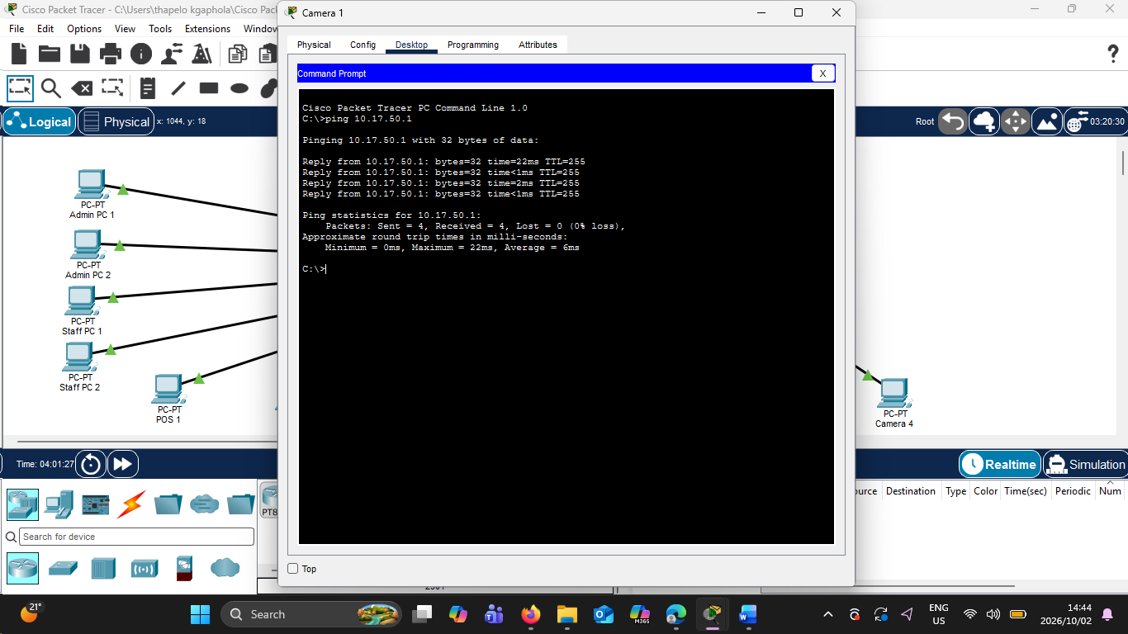
Figure above shows a successful ping from CCTV Camera 1 to the VLAN 50 default gateway (10.17.50.1), confirming that the CCTV network is operational.

Therefore, the CCTV connectivity tests were successful, and the CR7 change request was successfully implemented. Four CCTV cameras were added to the network and placed in the dedicated VLAN-50 CCTV using the 10.17.50.0/24 subnet.
In conclusion, the testing confirmed that the CCTV network was operational and segmented from the other VLANs. The contractor access-control configuration also prevented contractor devices from accessing the CCTV network while authorised internal communication remained operational.

Contractor Wireless Access Testing
The purpose of this test was to verify that the wireless network provided for after-hours cleaning and security contractors was operational.
A dedicated contractor network was implemented using VLAN 40 – CONTRACTOR WIFI. This separates contractor wireless devices from the main internal network and provides a network on which limited-access controls can be applied.
The contractor network uses the 10.17.40.0/24 subnet, with 10.17.40.1 configured as the default gateway.
Wireless Configuration
- VLAN: 40
- VLAN Name: CONTRACTOR WIFI
- Network: 10.17.40.0/24
- Default Gateway: 10.17.40.1
- Wireless SSID: Kgorong Contractor
- Security: WPA2-PSK
- Encryption: AES
Two contractor laptops were connected wirelessly to the access point.
The contractor devices use the following addresses:
- Contractor Laptop 1 – 10.17.40.10/24
- Contractor Laptop 2 – 10.17.40.11/24
- Default Gateway – 10.17.40.1
Testing Procedure
Contractor Laptop 1 was used to verify that the wireless connection and VLAN 40 gateway were operational.
The laptop was connected to the Kgorong-Contractor wireless network, and a ping test was performed to the VLAN 40 default gateway:
ping 10.17.40.1
A successful response from the gateway would confirm that the contractor laptop was correctly connected to the contractor wireless network.

Below are screenshots for this testing.

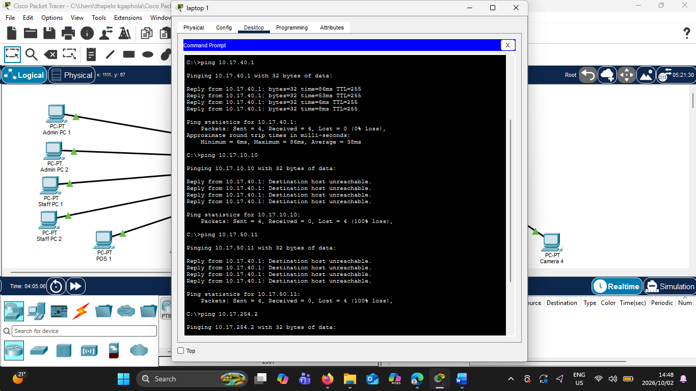
Figure: Successful ping from Contractor Laptop 1 to the VLAN 40 default gateway (10.17.40.1), confirming that the contractor wireless network is operational.

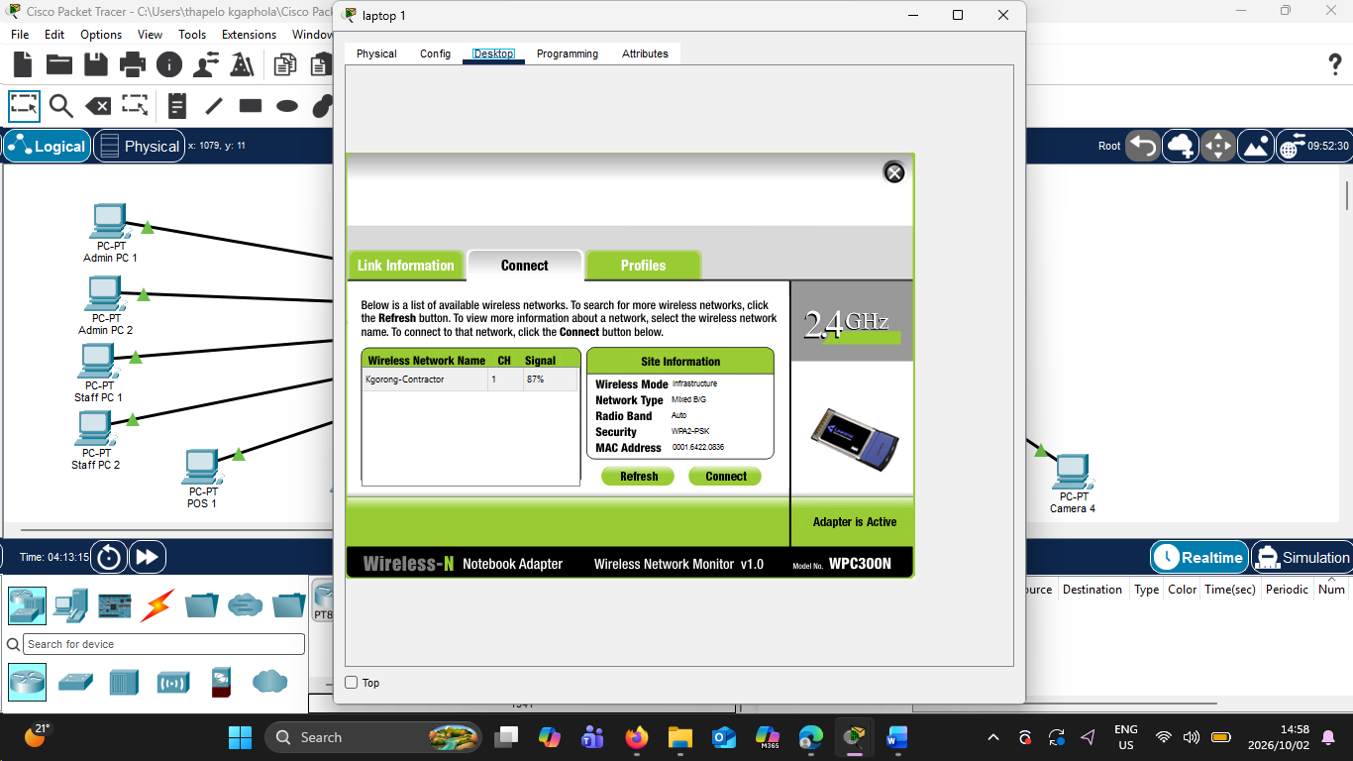
Figure: Contractor Laptop 1 wireless configuration showing the Kgorong-Contractor wireless network using WPA2-PSK security.

Therefore, contractor Laptop 1 successfully communicated with the VLAN 40 default gateway at 10.17.40.1.
Four ICMP replies were received, confirming that the wireless connection, IP addressing and gateway configuration were operating correctly.
In conclusion, additional testing also demonstrated that the contractor device could reach permitted destinations outside the protected internal VLAN’s. The access restrictions applied to the contractor network are tested separately below.

Contractor Access-Control Testing
The purpose of this test was to verify that devices connected to the contractor wireless network had limited access to the organisation's network resources.
Access-Control Configuration
The CONTRACTOR_LIMIT ACL was configured to prevent devices in the contractor network from accessing the following protected internal VLANs:
- VLAN 10 – ADMIN
- VLAN 20 – POS
- VLAN 30 – STAFF
- VLAN 50 – CCTV
- VLAN 60 – MANAGEMENT
Traffic from the contractor network that does not match these restrictions is permitted by the final ACL rule.
Testing Procedure
Contractor Laptop 1 was used to test the access restrictions.
The following tests were performed:
- Ping the contractor VLAN gateway at 10.17.40.1.
- Ping Admin PC 1 at 10.17.10.10.
- Ping CCTV Camera 1 at 10.17.50.11.
- Ping router address 10.17.254.2 to verify that permitted traffic could still pass through the network.
The expected results were that the contractor gateway and permitted destination would remain reachable, while access to the protected Admin and CCTV networks would be blocked.

The test results matched the intended access-control policy.
Contractor Laptop 1 successfully communicated with its default gateway at 10.17.40.1.
Attempts to reach Admin PC 1 at 10.17.10.10 and CCTV Camera 1 at 10.17.50.11 were blocked. The laptop received destination-unreachable responses from 10.17.40.1, and the ping statistics showed 100% packet loss for both protected destinations.
A test to 10.17.254.2 was successful, demonstrating that the contractor laptop had not simply lost all network connectivity. Instead, the ACL selectively restricted access to protected internal networks while allowing permitted traffic.

The ACL was verified on R1 using the show access-lists command.
The ACL match counters showed that packets destined for the protected Admin and CCTV networks were denied, while permitted contractor traffic matched the final permit rule.
The ACL was also verified on the VLAN 40 router sub interface. The show Ip interface gigabitethernet0/2.40 command confirmed that CONTRACTOR LIMIT was applied as an inbound access list.
Below are the screenshots of this testing
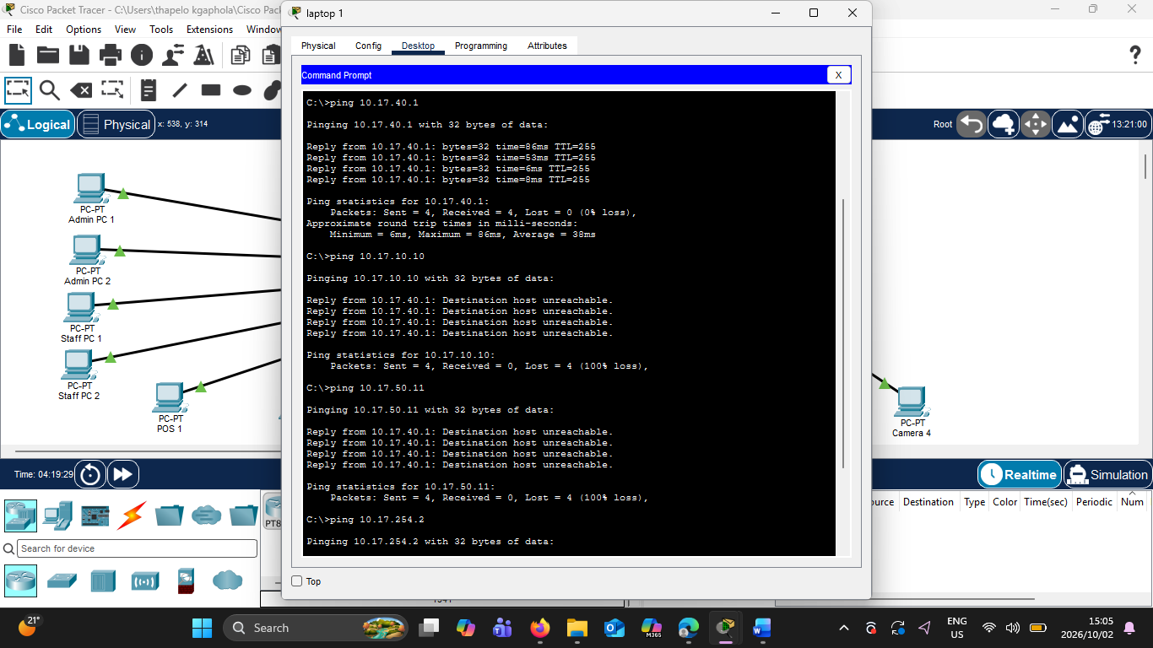
Figure: Contractor Laptop 1 successfully reaching its VLAN 40 gateway while access to the Admin and CCTV networks is blocked by the CONTRACTOR_LIMIT ACL.

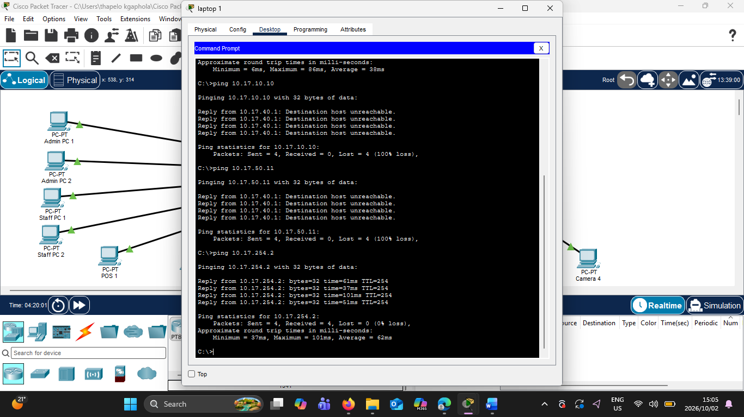
Figure: Successful ping from Contractor Laptop 1 to 10.17.254.2, demonstrating that permitted traffic remains operational while access to protected VLANs is restricted.

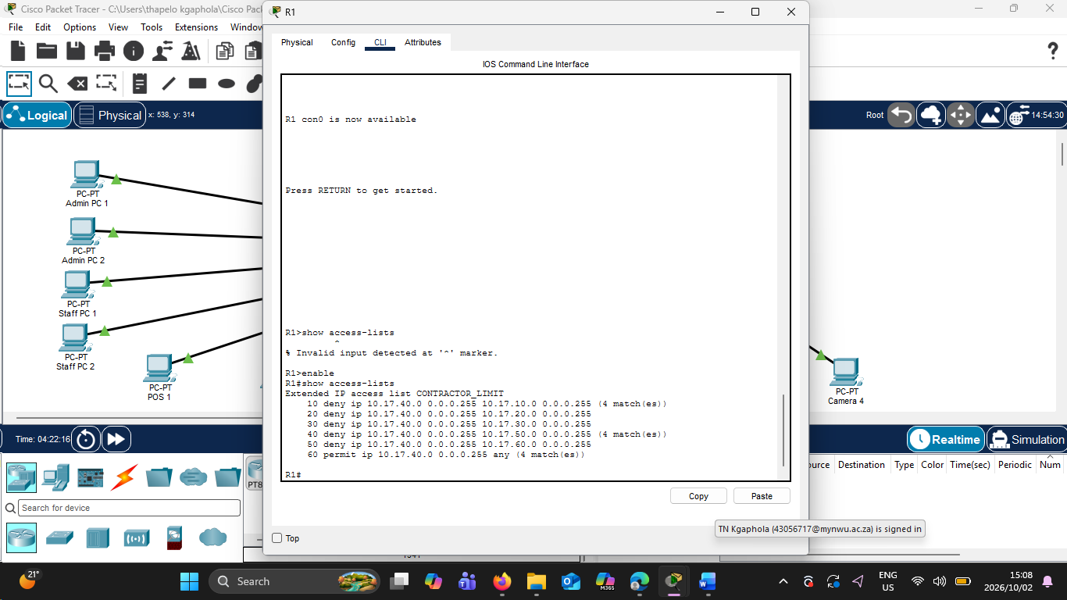
Figure: R1 CONTRACTOR_LIMIT extended ACL showing packet matches for denied Admin and CCTV traffic and permitted contractor traffic.
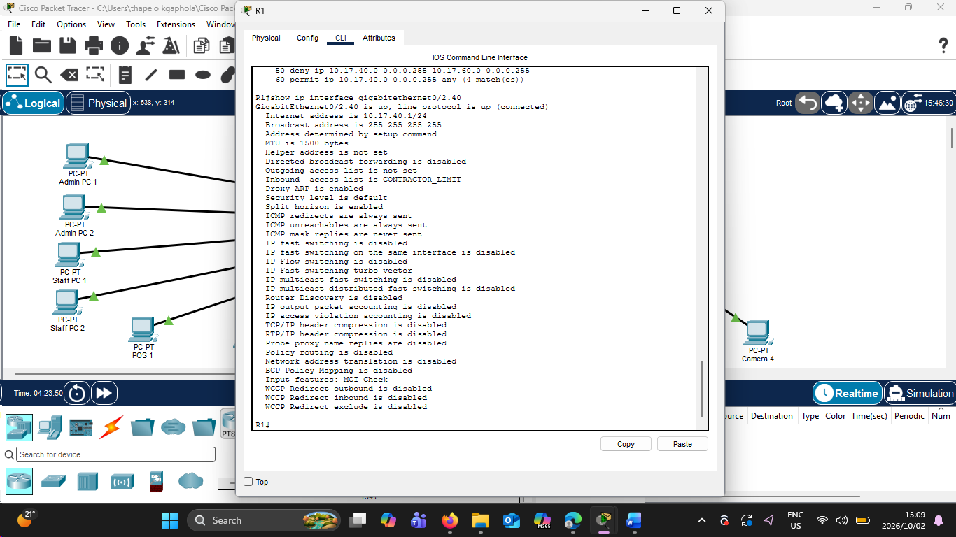
Figure: R1 GigabitEthernet0/2.40 interface showing the CONTRACTOR_LIMIT ACL applied inbound to the contractor VLAN.

Therefore, the contractor access-control testing was successful. Contractor devices retained basic network connectivity while access to protected internal networks was restricted.
In conclusion, the results demonstrate that VLAN 40 provides limited contractor wireless access and that the CONTRACTOR LIMIT ACL successfully enforces the required separation between contractor devices and sensitive internal resources.

Static Routing Testing
The purpose of this test was to verify the implementation of the assigned networking feature, Static Routing (Multi-Router Path Control).
Three routers, R1, R2 and R3, were connected using point-to-point /30 networks. Static routes were manually configured to provide communication between remote networks and to define the next-hop routers used to reach specific destinations.
Router-to-Router Networks
The following /30 networks were used between the routers:
- R1–R2: 10.17.254.0/30
- R2–R3: 10.17.254.4/30
- R1–R3: 10.17.254.8/30
These /30 networks are subnets of the assigned 10.17.0.0/16 address block and provide two usable addresses on each point-to-point router link.
Testing Procedure
The show Ip route command was executed on R1, R2 and R3 to verify that the required static routes were installed in their routing tables.
The letter S in the Cisco routing table identifies a manually configured static route.
The routing tables were checked to confirm both directly connected networks and the required static routes.
R1 Routing Verification
R1 showed its six directly connected VLAN networks and its directly connected router links.
The following static route was present:
S 10.17.254.4/30 [1/0] via 10.17.254.2
This instructs R1 to reach the R2–R3 transit network 10.17.254.4/30 through the next-hop address 10.17.254.2.
R2 Routing Verification
R2 contained the following static routes:
S 10.17.0.0/16 [1/0] via 10.17.254.1
S 10.17.254.8/30 [1/0] via 10.17.254.6
The first route directs traffic for the organisation's internal networks toward R1 through 10.17.254.1.
The second route directs traffic destined for the 10.17.254.8/30 network through R3 at 10.17.254.6.
R3 Routing Verification
R3 contained the following static routes:
S 10.17.0.0/16 [1/0] via 10.17.254.9
S 10.17.254.0/30 [1/0] via 10.17.254.5
The first route directs traffic destined for the organisation's internal networks toward R1 through 10.17.254.9.
The second route directs traffic destined for the 10.17.254.0/30 network through R2 at 10.17.254.5.

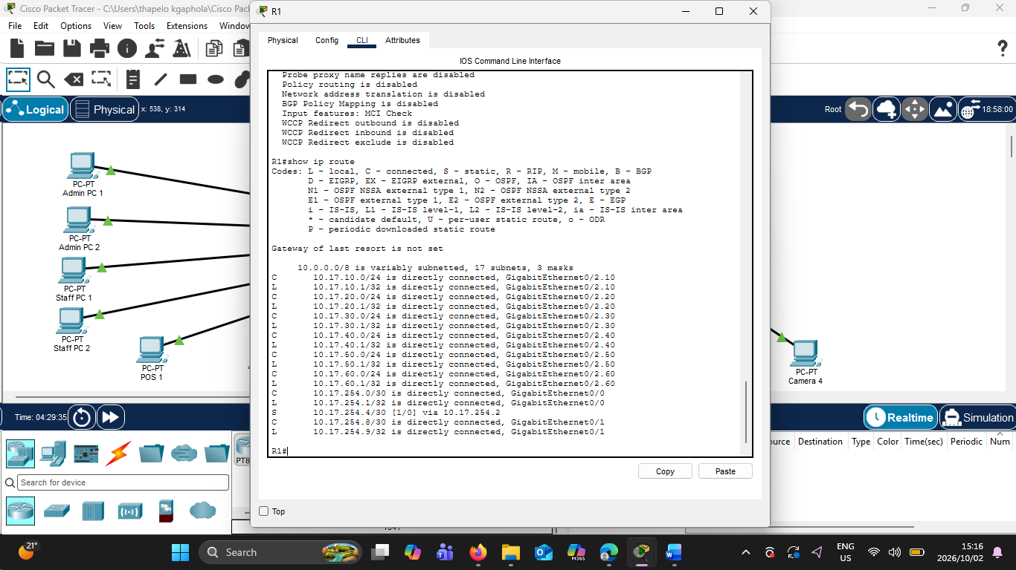
Figure: R1 routing table showing the static route to 10.17.254.4/30 via next-hop 10.17.254.2, together with the directly connected VLAN and router networks.
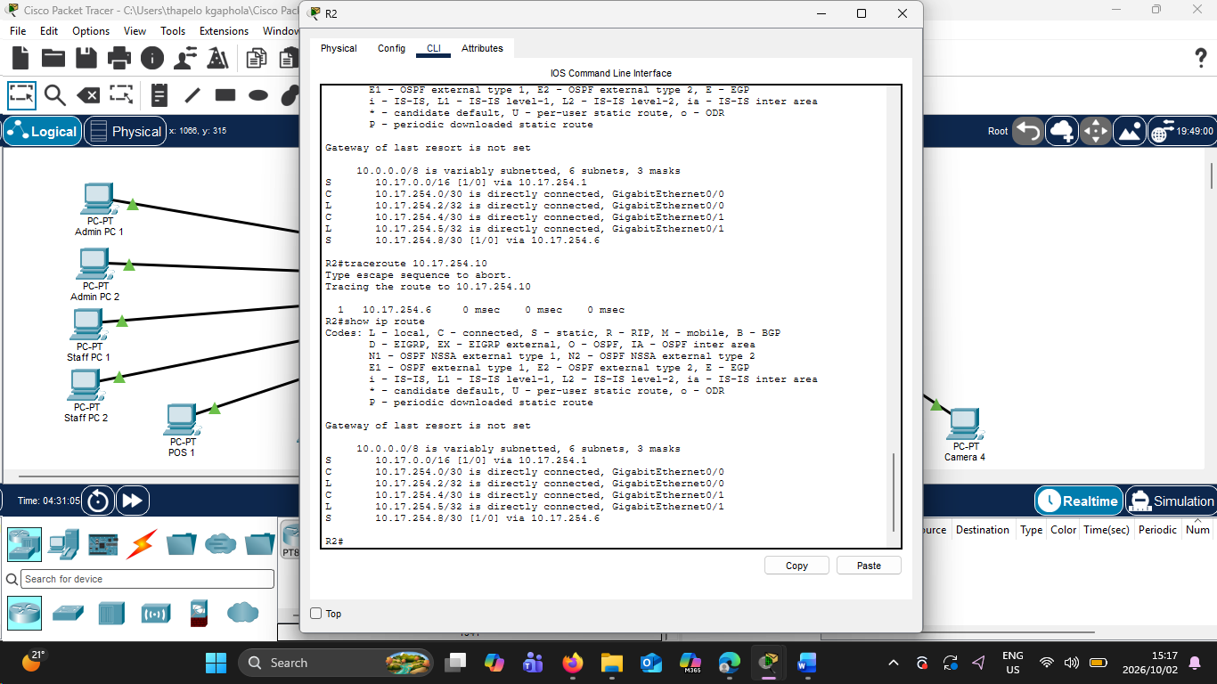
Figure: R2 routing table showing static routes to 10.17.0.0/16 via 10.17.254.1 and 10.17.254.8/30 via 10.17.254.6.

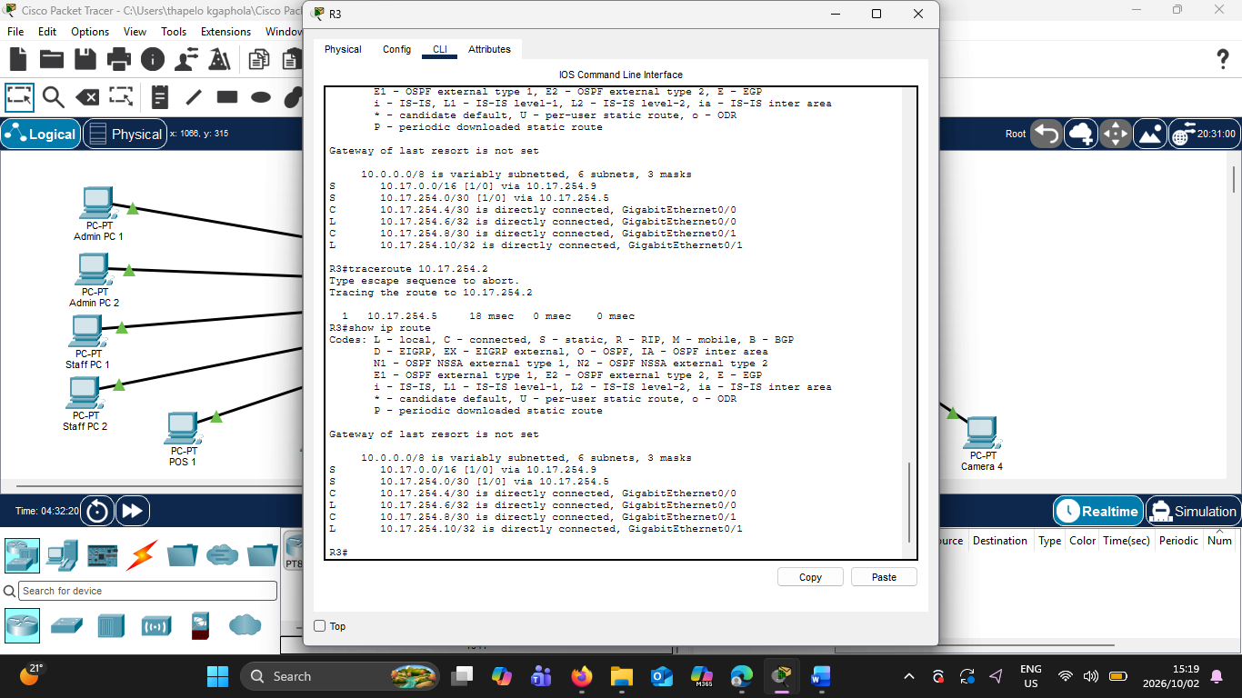
Figure: R3 routing table showing static routes to 10.17.0.0/16 via 10.17.254.9 and 10.17.254.0/30 via 10.17.254.5.

Therefore, the routing tables on all three routers contained the expected static routes.
The static routes provided reachability to networks that were not directly connected and specified the required next-hop routers. This confirms that the static-routing configuration was successfully installed on R1, R2 and R3.
The actual forwarding paths produced by these routes are demonstrated using traceroute testing in Section 7.
In conclusion, static routing was successfully implemented across the three-router topology.

Multi-Router Path-Control Verification
The purpose of this test was to verify that the configured static routes were not only present in the routing tables but were actively controlling the paths used by traffic between the three routers.
The traceroute command was used because it displays the intermediate next-hop routers used to reach a destination.
R1 Path-Control Test
From R1, a traceroute was performed to 10.17.254.6 using:
traceroute 10.17.254.6
The result showed:
1 10.17.254.2
2 10.17.254.6
This confirms that R1 did not attempt to reach the destination through its direct R1–R3 link. Instead, the configured static route caused the traffic to travel through R2 at 10.17.254.2 before reaching R3 at 10.17.254.6.
The observed path was therefore:
R1 → R2 → R3
This demonstrates deliberate multi-router path control.
R2 Path-Control Test
From R2, a traceroute was performed to 10.17.254.10 using:
traceroute 10.17.254.10
The traceroute showed 10.17.254.6 as the next hop.
This corresponds with R2's static route for 10.17.254.8/30, which uses 10.17.254.6 as its next hop.
The result confirms that R2 forwarded the traffic through R3 as intended.
R3 Path-Control Test
From R3, a traceroute was performed to 10.17.254.2 using:
traceroute 10.17.254.2
The result showed:
1 10.17.254.5
The address 10.17.254.5 belongs to R2 on the R2–R3 connection. This corresponds with R3's static route directing traffic for 10.17.254.0/30 through 10.17.254.5.
The result therefore confirms that R3 uses R2 as the configured next hop for this destination.
Below are the screenshots for this verification
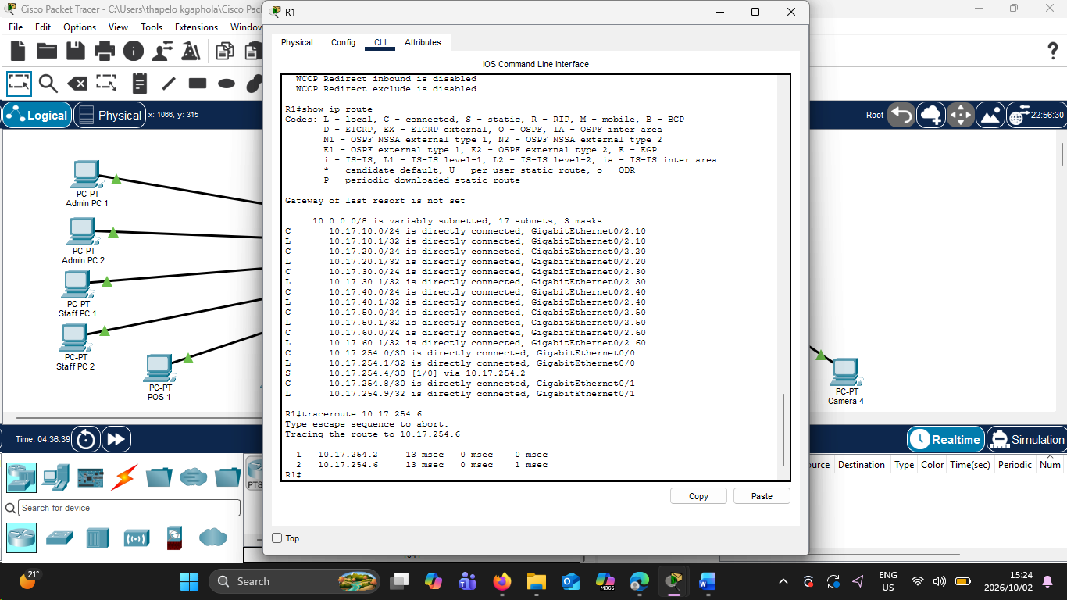
Figure: R1 traceroute to 10.17.254.6 showing traffic forwarded through R2 (10.17.254.2) before reaching R3, demonstrating static multi-router path control.

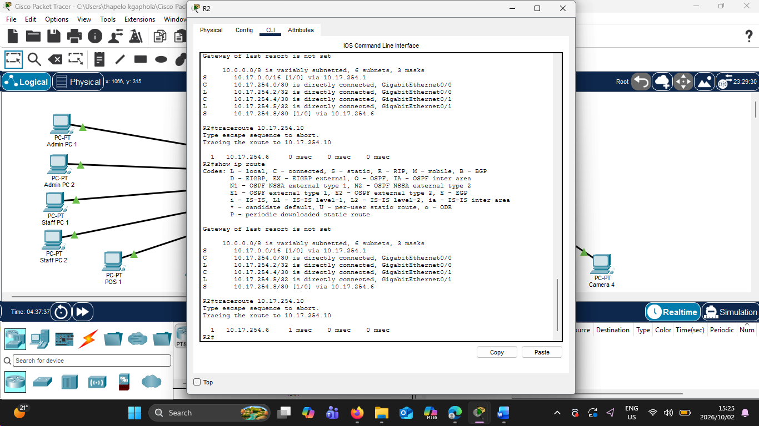
Figure: R2 traceroute to 10.17.254.10 showing traffic forwarded through R3 (10.17.254.6), confirming the configured static path.
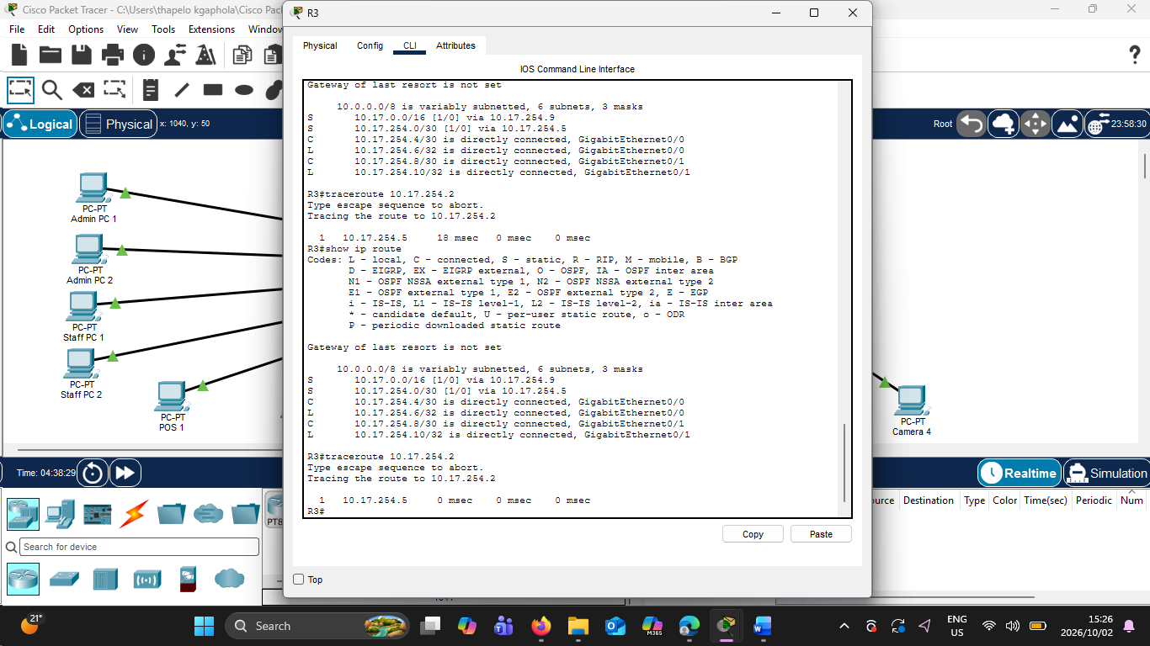
Figure: R3 traceroute to 10.17.254.2 showing traffic forwarded through R2 (10.17.254.5), confirming the configured static path.

Therefore, all three traceroute tests followed the paths specified by the configured static routes.
The tests demonstrate that static routing was used to deliberately control forwarding paths across the three-router topology rather than relying on a dynamic routing protocol.
The R1 test provides a particularly clear demonstration of multi-router path control because traffic to 10.17.254.6 travelled through R2 before reaching R3.

Troubleshooting Performed
During the implementation and testing of the Kgorong Butchery & Deli network, several connectivity and configuration problems were encountered. Troubleshooting commands and connectivity tests were used to identify and resolve these problems.
CCTV VLAN Connectivity Problem
During the initial configuration of the CCTV network, Camera 1 could not successfully communicate with the VLAN 50 default gateway at 10.17.50.1.
The CCTV VLAN configuration, switch-port assignments, trunk links and R1 VLAN 50 sub interface were checked. The CCTV switch ports connected to the cameras were assigned to VLAN 50, and the uplink was configured to carry VLAN 50 traffic.
After correcting and verifying the VLAN and trunk configuration, Camera 1 successfully reached 10.17.50.1. Connectivity to the remaining CCTV cameras was also verified.
This troubleshooting confirmed that the four CCTV devices added under change request CR7 were operating correctly on the dedicated CCTV network.
VLAN 10 Connectivity Problem
During testing, communication with the VLAN 10 gateway at 10.17.10.1 initially failed.
The VLAN configuration, trunk configuration and R1 router sub interface were checked. VLAN 10 was confirmed on the switch, and the router-on-a-stick configuration was verified.
After the relevant VLAN and trunk settings were corrected, VLAN 10 connectivity was restored.
Router-to-Router Connectivity and Static Routing
During the implementation of the three-router topology, some router-to-router destinations were initially unreachable because the routers only knew about their directly connected networks.
For example, an initial traceroute from R1 toward 10.17.254.6 did not successfully reach the destination.
The routing tables were examined using show ip route. A static route was then configured on R1 to reach the 10.17.254.4/30 network through next-hop 10.17.254.2.
After the route was added, R1 successfully reached 10.17.254.6, and traceroute showed the following path:
R1 → 10.17.254.2 → 10.17.254.6
Additional static routes were configured and verified on R2 and R3 to provide the required reachability and path control.
This troubleshooting process demonstrated why static routes were necessary for communication between networks that were not directly connected.
Contractor Access-Control Verification
After the CONTRACTOR LIMIT ACL was configured, both permitted and denied traffic were tested to ensure that the ACL was not unintentionally blocking all contractor traffic.
Contractor Laptop 1 could successfully communicate with its VLAN 40 gateway at 10.17.40.1 and with the permitted router destination 10.17.254.2.
Attempts to reach Admin PC 1 at 10.17.10.10 and CCTV Camera 1 at 10.17.50.11 were blocked as intended.
The show access-lists command was used to examine ACL match counters. The counters confirmed that the Admin and CCTV test packets matched the deny rules, while permitted traffic matched the final permit rule.
The show Ip interface gigabitethernet0/2.40 command was also used to confirm that CONTRACTOR LIMIT was applied inbound on the correct R1 sub interface.
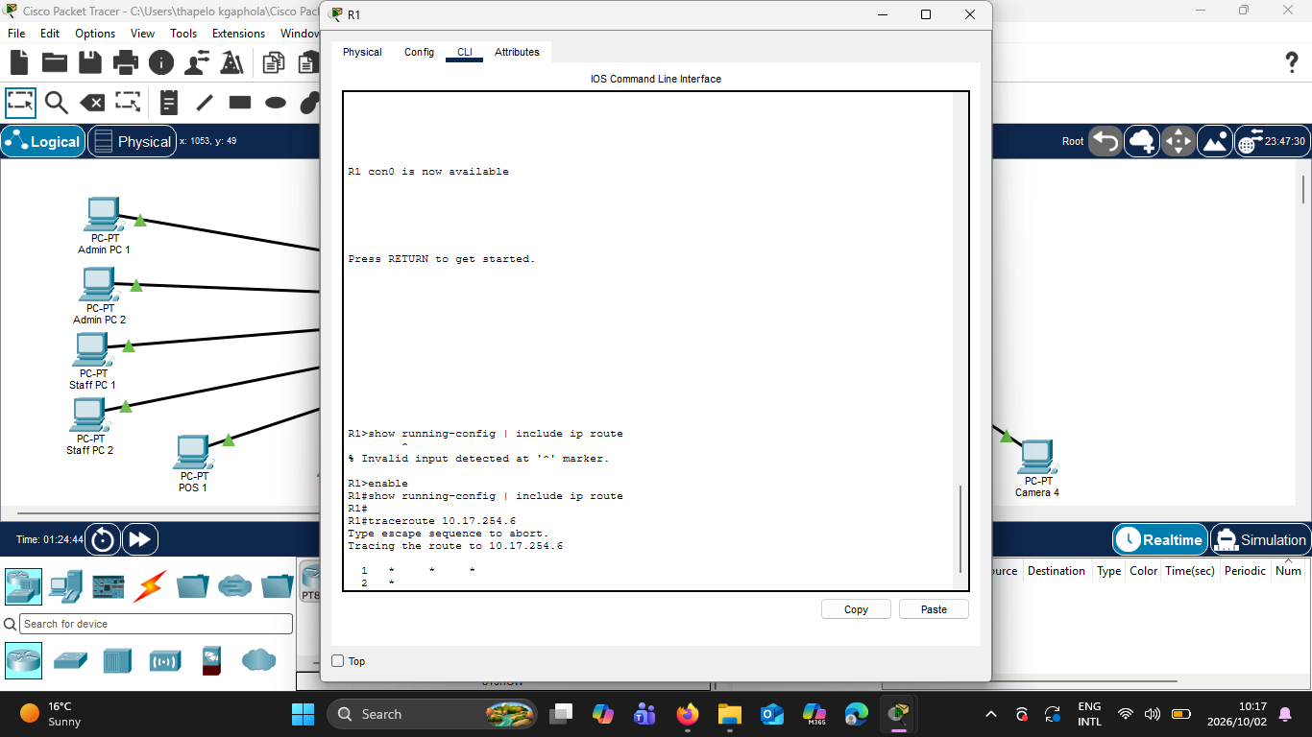
Figure above is the R1 traceroute that was not working.

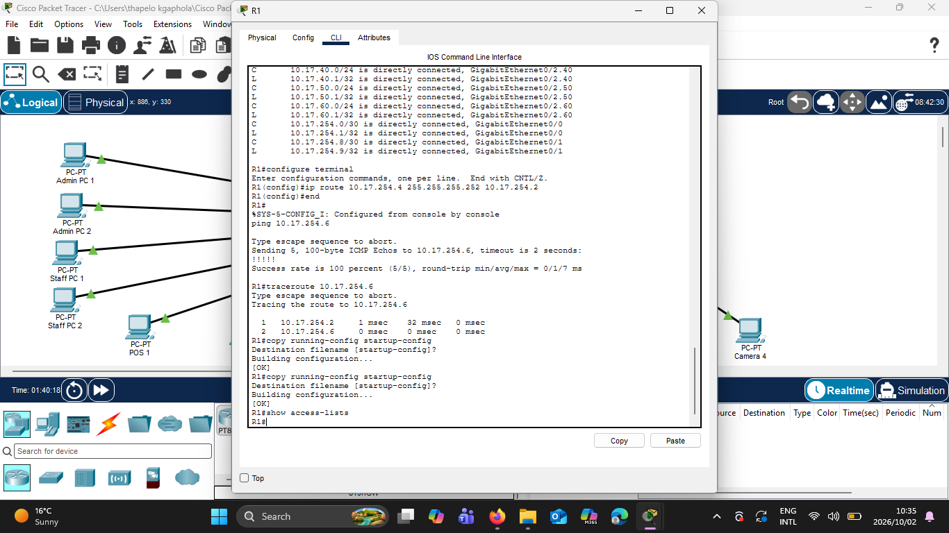
Figure above is the working traceroute of R1.
Therefore, the troubleshooting process helped identify VLAN, trunking, routing and access-control issues during implementation and they were all corrected.

Test Results Summary
The following table summarises the main tests performed on the Kgorong Butchery & Deli network and the results obtained after perfoming the tests.
TEST | SOURCE | DESTINATION | EXPECTED RESULT | ACTUAL RESULT | STATUS
Inter-VLAN – POS | Admin PC 1 | 10.17.20.10 | Reachable | Successful ping | pass
Inter-VLAN – Staff | Admin PC 1 | 10.17.30.10 | Reachable | Successful ping | pass
Inter-VLAN – Contractor | Admin PC 1 | 10.17.40.10 | Reachable | Successful ping | pass
Inter-VLAN – CCTV | Admin PC 1 | 10.17.50.11 | Reachable | Successful ping | pass
Management VLAN | Admin PC 1 | 10.17.60.1 | Reachable | Successful ping | pass
CCTV Gateway | Camera 1 | 10.17.50.1 | Reachable | 4/4 replies | pass
Contractor Gateway | Contractor Laptop 1 | 10.17.40.1 | Reachable | 4/4 replies | pass
Contractor → Admin | Contractor Laptop 1 | 10.17.10.10 | Blocked | 100% packet loss | pass
Contractor → CCTV | Contractor Laptop 1 | 10.17.50.11 | Blocked | 100%packet loss | pass
Contractor Permitted Traffic | Contractor Laptop 1 | 10.17.254.2 | Reachable | 4/4/ replies | pass
R1 Static Path | R1 | 10.17.254.6 | Via R2 | 10.17.254.2 → 10.17.254.6 | pass
R2 Static Path | R2 | 10.17.254.10 | Via R3 | Next hop 10.17.254.6 | pass
R3 Static Path | R3 | 10.17.254.2 | Via R2 | Next hop 10.17.254.5 | pass

Based on the tests performed, the implemented network successfully met the tested technical requirements and the client requirements for Kgorong Butchery and Deli. The client CR7 request was successfully implemented and accommodated. The contractor wireless network was successfully implemented. The static routing (multi router path control) was also successfully implemented across three routers (R1,R2,R3).

